Mini Twitter API
Project Report
Web Development — Node.js / Express

Student Information
Name: Michael Maged Fawzy
ID: 22P0005
GitHub Repository: https://github.com/Michael-Maged/IP-Labs

Project Overview
This project implements a RESTful API that simulates core posting functionality similar to Twitter. Built with Node.js and Express, the API supports full CRUD operations on posts stored in-memory. It is lightweight, straightforward, and demonstrates fundamental backend development concepts.

API Endpoints

Method | Route | Description | Status
GET | / | Health check — API status | 200
GET | /posts | Retrieve all posts | 200
POST | /posts | Create a new post | 201 / 400
GET | /posts/:id | Get a single post by ID | 200 / 404
PUT | /posts/:id | Update post content by ID | 200 / 400 / 404
DELETE | /posts/:id | Delete a post by ID | 200 / 404

Request & Response Details

POST /posts — Create Post
Request Body (JSON):
{ "content": "Hello world!", "author": "Alice" }
Response: Returns the created post object with auto-assigned ID. Author defaults to 'anonymous' if omitted.

PUT /posts/:id — Update Post
Request Body (JSON):
{ "content": "Updated content here" }
Response: Returns the updated post object. Returns 404 if post ID does not exist.

Code Screenshot

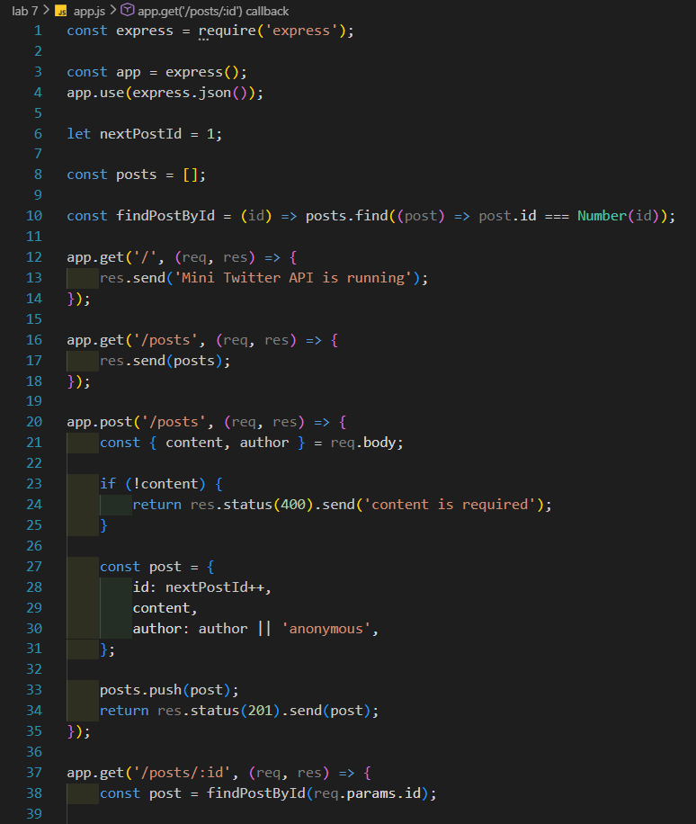
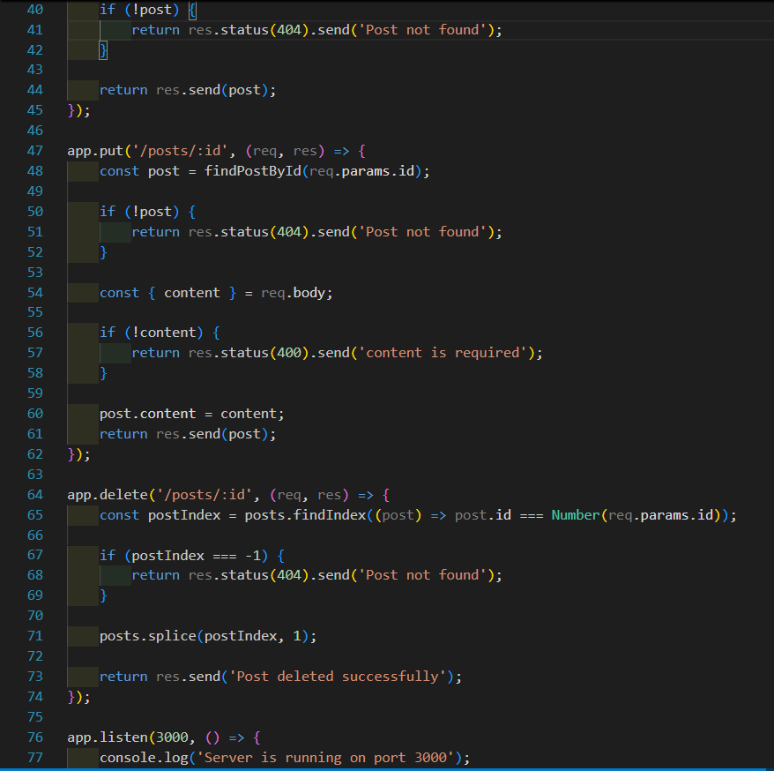

API Testing — Thunder Client
All endpoints were tested using Thunder Client (VS Code extension). Screenshots below demonstrate each request and its corresponding response.

Test 1 — GET /
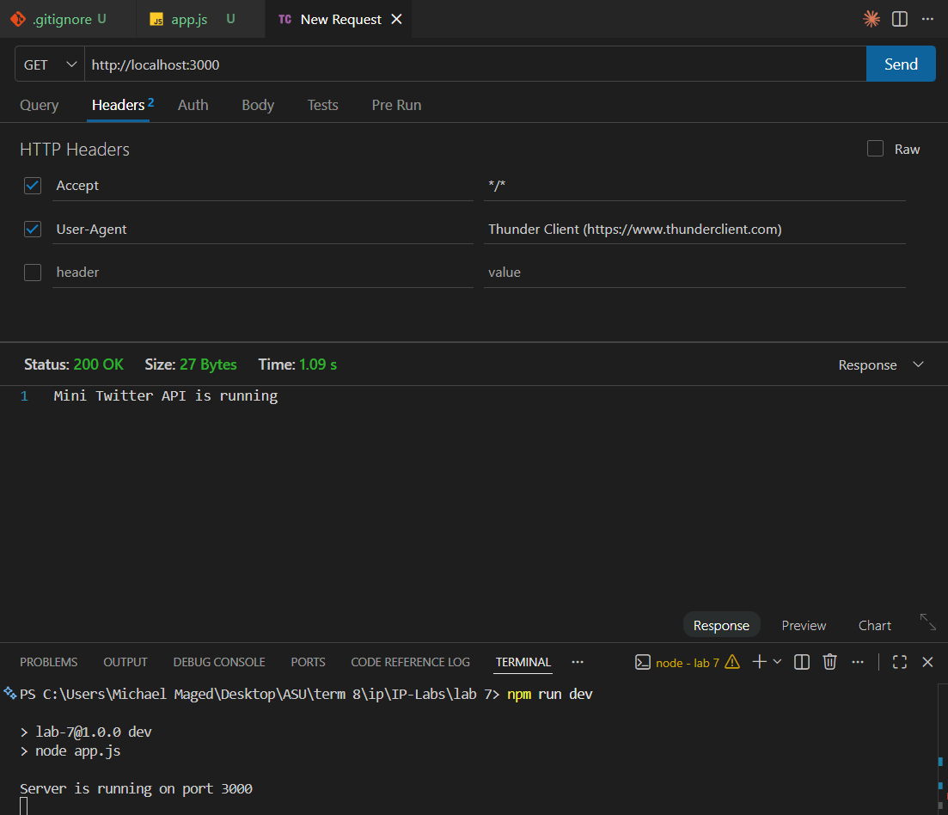

Test 2 — POST /posts (Create Post)
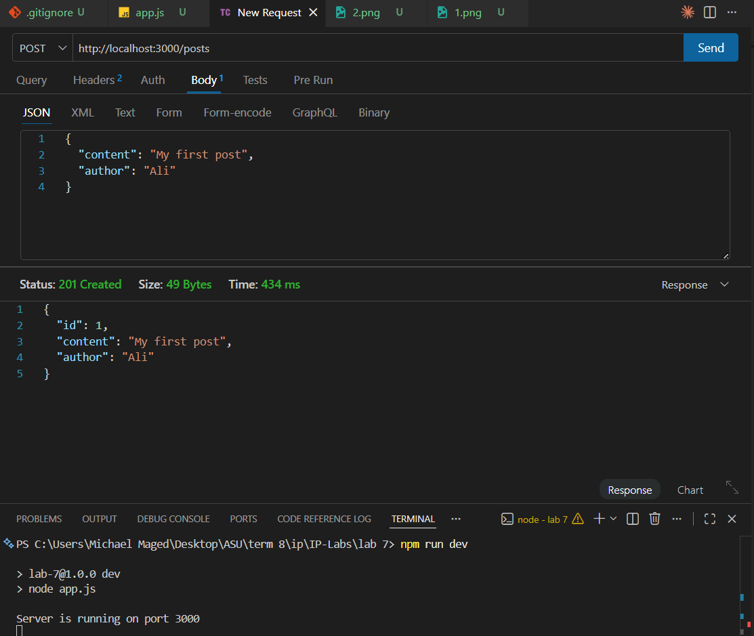

Test 3 — GET /posts/:id (Single Post)
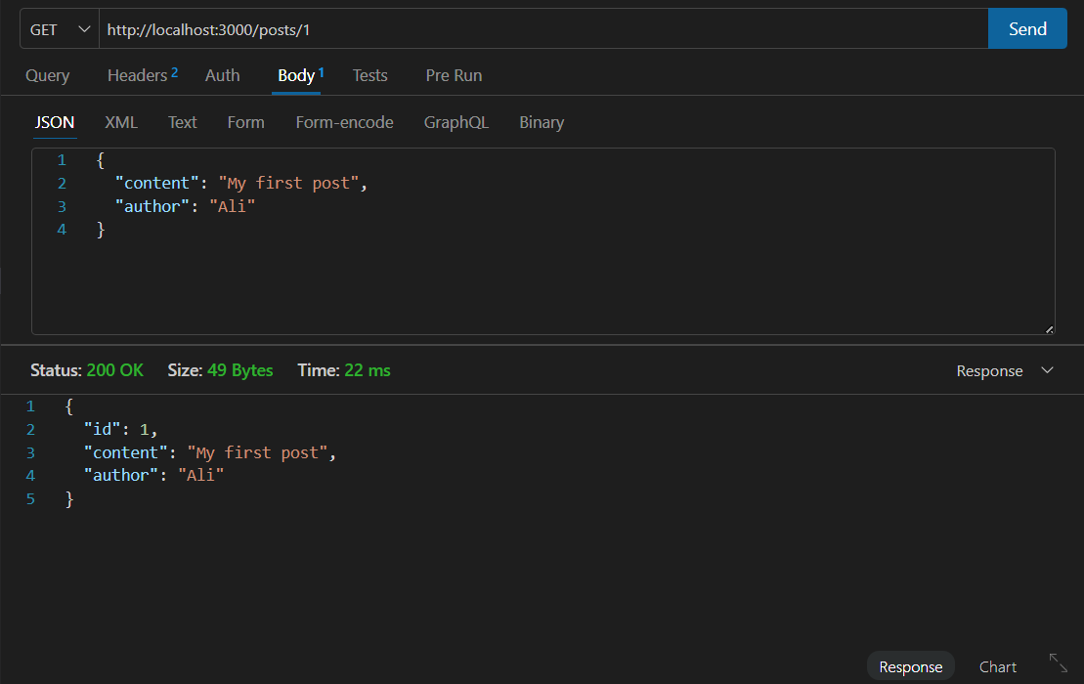

Test 4 — PUT /posts/:id (Update Post)
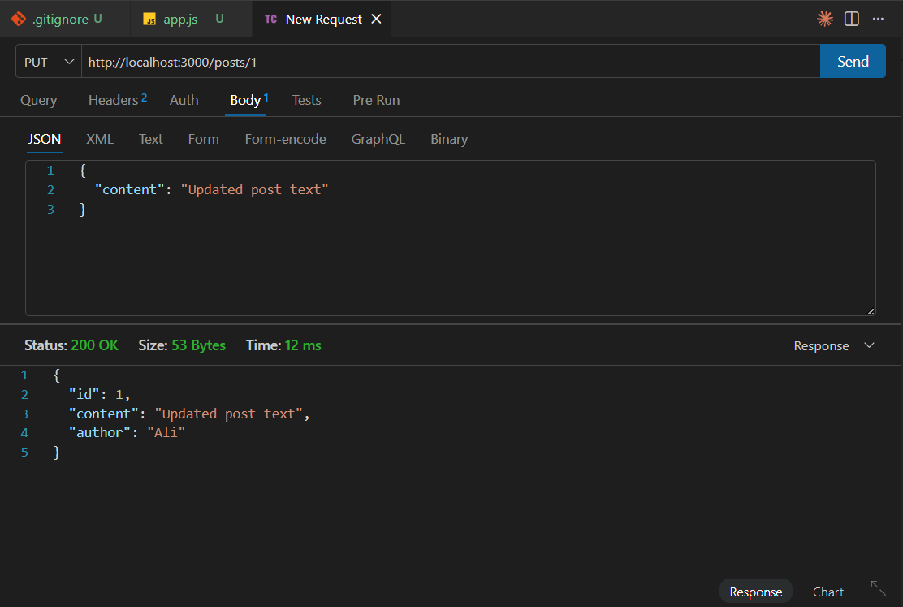

Test 5 — DELETE /posts/:id (Delete Post)
